Ex. No.: 4a)
Date:
EMPLOYEE AVERAGE PAY
Aim:
To find out the average pay of all employees whose salary is more than 6000 and no. of
days worked is more than 4.
Algorithm:
1. Create a flat file emp.dat for employees with their name, salary per day and number of days
worked and save it.
2. Create an awk script emp.awk
3. For each employee record do
a. If Salary is greater than 6000 and number of days worked is more than 4, then print name and
salary earned
b. Compute total pay of employee
4. Print the total number of employees satisfying the criteria and their average pay.

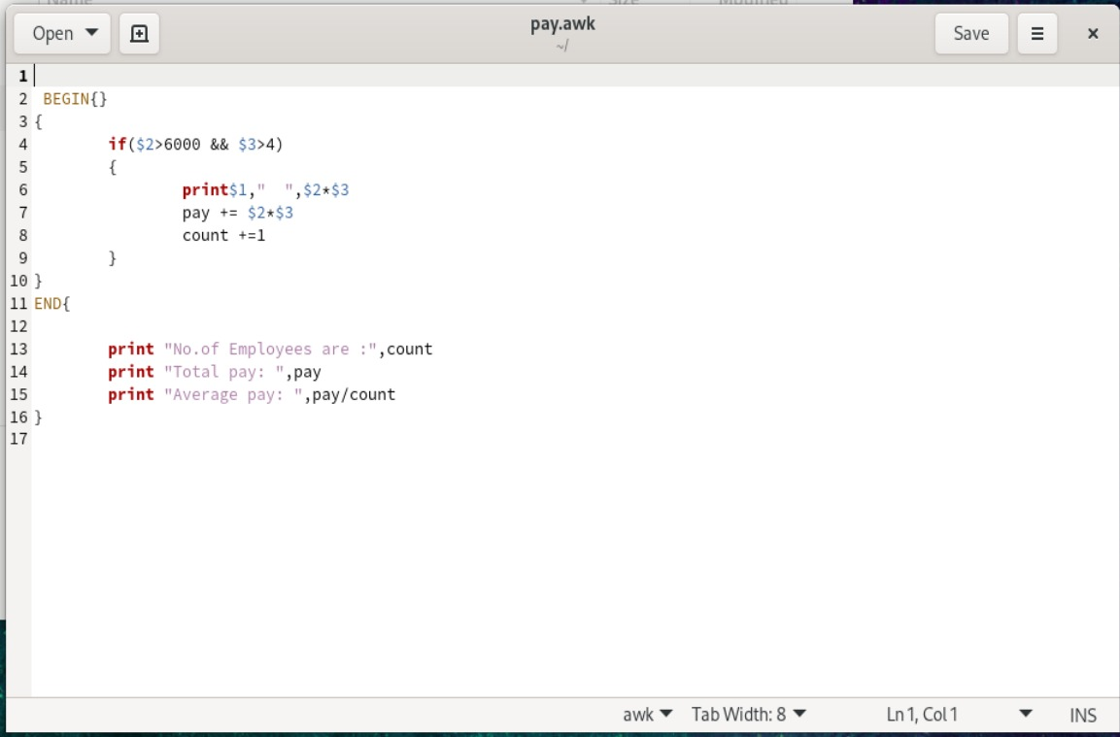

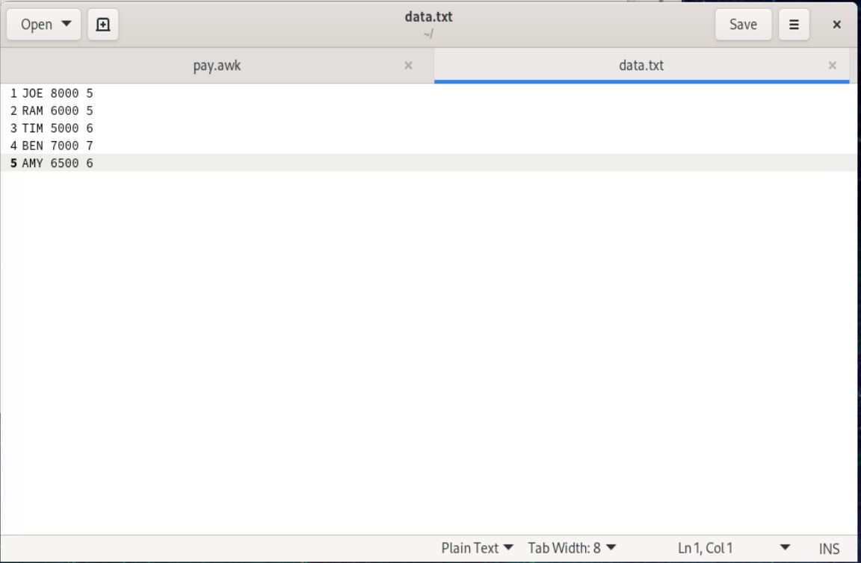

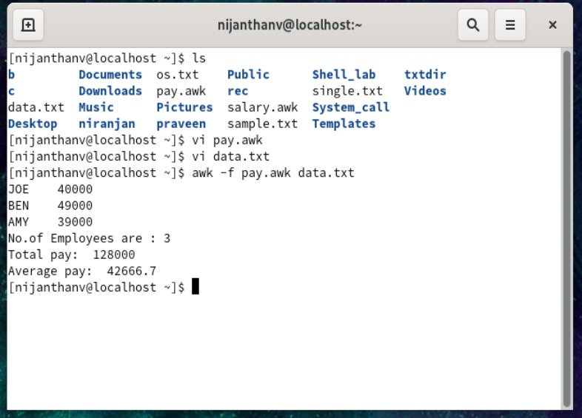

Ex. No.: 4b)
Date:
RESULTS OF EXAMINATION
Aim:
To print the pass/fail status of a student in a class.
Algorithm:
1. Read the data from file
2. Get a data from each column
3. Compare the all subject marks column
a. If marks less than 45 then print Fail
b. else print Pass

